**Promo Stack:**

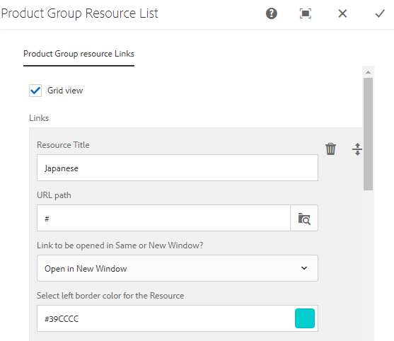

* Instead of a check box, add a drop down for “Layout Type” with options of “Stacked” and “2 Column”. Stacked can be set as the default.
* Change the Label to “Title”
* Change the Label to “Link Target”
* Color should be a drop down and the label should be “Select Left Border Color”
* Everything should be a mandatory field.
* Adjust the main title to match the Module name.

**Ribbon:**

* Background and Font color should be 2 drop down fields. These fields should be shown after the rest of the fields
* Ribbon Text should be the first field followed by “URL”
* URL target field should be added
* All the fields should be Mandatory in this module

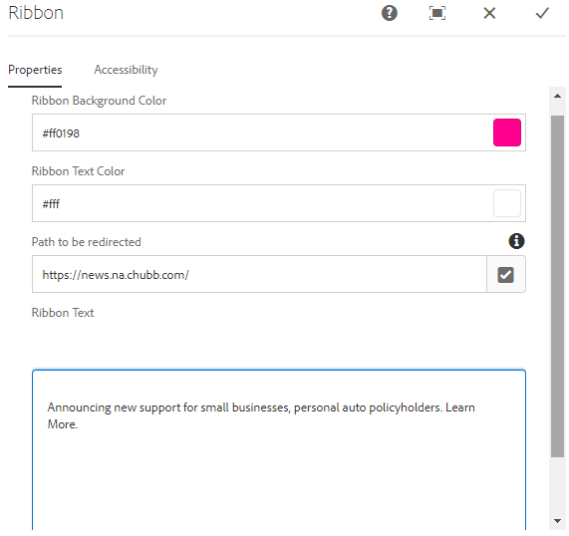

**Text:**



* No Separate module is needed for this.
* Intro text or the simple RTF module with Font size option that I suggested on 06/09 is sufficient for this requirement

**Image – Story page template**:

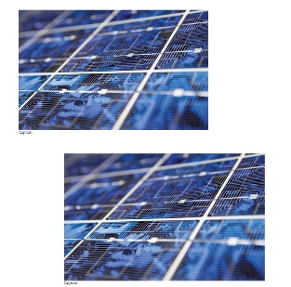

This should be a multi select input panel with the following fields

* Image URL
* Decorative checkbox and Alt text field
* “Caption” field (Optional)
* Image Size – Drop down field with options “Original” (default selection), “Medium” and “Large”
  + If Original – Display the image in its original size (newly added option. Not in CP)
  + Medium – Implement similar to CP with enough padding based on the alignment
  + Large – Full Width Image
* If the Image Size is “Original” or “Medium” then show another drop down field “Image Alignment” with Options “Center” (newly added in CP) / “Right” / “Left” with Center being the default
* Except Caption, all other fields should be mandatory